**Experiment no.05 Achyuta.M**

**125010005**

**Simulation of CSTR for liquid phase reaction**

**Objective**

Develop a simple process sheet to determine the exit composition from a continuous stirred

tank reactor (CSTR)

**Data**

Reaction: Ethylene glycol production in CSTR: Ethylene oxide reacts with water to form

Ethylene Glycol

Inlet stream: 26 m3/hr of aqueous solution of Ethylene oxide with a concentration of 8 mol/l

Reaction carried out at 550degC under atmospheric condition in CSTR of 2 m3

k: rate constant = 0.0051/s

**Aspen Blocks Used**

Reactors (RCSTR)

**Flowsheet**

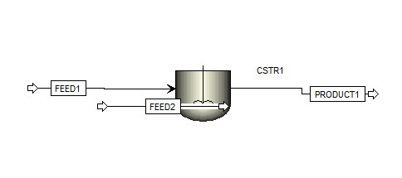

**Results**

|  |  |  |  |  |
| --- | --- | --- | --- | --- |
| Temperature | C | 30 | 20 | 30 |
| Pressure | bar | 1 | 1 | 1 |
| Molar Vapor Fraction |  | 0.0603907589 | 0.3877204967 | 1 |
| Molar Liquid Fraction |  | 0.9396092411 | 0.6122795033 | 0 |
| Molar Solid Fraction |  | 0 | 0 | 0 |
| Mass Vapor Fraction |  | 0.0845826279 | 0.4377408178 | 1 |
| Mass Liquid Fraction |  | 0.9154173721 | 0.5622591822 | 0 |
| Mass Solid Fraction |  | 0 | 0 | 0 |
| Molar Enthalpy | kcal/mol | -42.9161388882 | -26.2293657058 | -35.1149805734 |
| Mass Enthalpy | kcal/kg | -1382.8650724339 | -675.2212994362 | -1131.492287332 |
| Molar Entropy | cal/mol-K | -42.8440269457 | -41.1564427231 | -19.5220092736 |
| Mass Entropy | cal/gm-K | -1.3805414457 | -1.0594883249 | -0.629047847 |
| Molar Density | mol/cc | 0.0006439076 | 0.0001055506 | 3.96748386782722E-05 |
| Mass Density | kg/cum | 19.9831701497 | 4.1001748041 | 1.231277672 |
| Enthalpy Flow | Gcal/hr | -1.2874841666 | -0.7868809712 | -1.0534494172 |
| Average MW |  | 31.03422 | 38.845584 | 31.03422 |
| Mole Flows | kmol/hr | 30 | 30 | 60 |
| Mole Fractions |  |  |  |  |
| Mass Flows | kg/hr | 931.0266 | 1165.36752 | 931.0266 |
| Mass Fractions |  |  |  |  |
| Volume Flow | cum/hr | 46.5905355869 | 284.223862562 | 756.14674185 |

**Verification**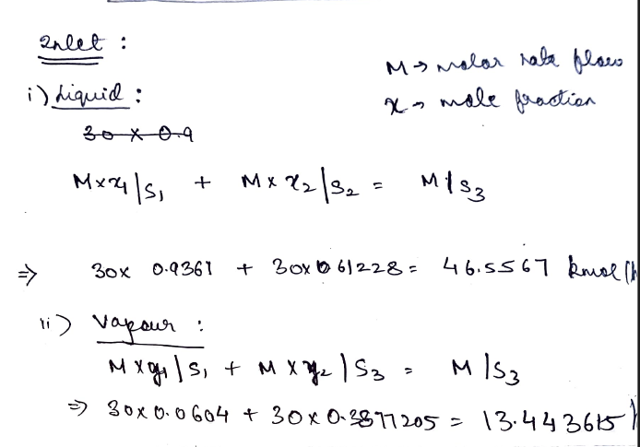

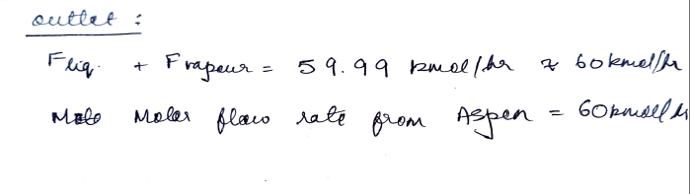

**Specific Learning**

By using this software, we can effectively model and analyse CSTR systems to gain knowledge about their working and optimize their performance for various chemical engineering applications.

Simulating a Continuous Stirred Tank Reactor (CSTR) using Aspen software taught me various aspects like -setting up components, defining reactions, configuring operating conditions, running simulations, and analysing results